**47th Annual Symposium by the Sea**



**May 2025**

**Monday, 19th**

**Tuesday, 20th**

**Wednesday, 21st**

**Conference Agenda & Program**

*Sponsored by the*

*Virginia Society for Respiratory Care*

*Program Applied for AARC* ***15*** *CEU’s*

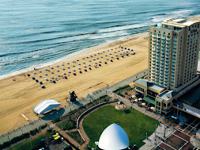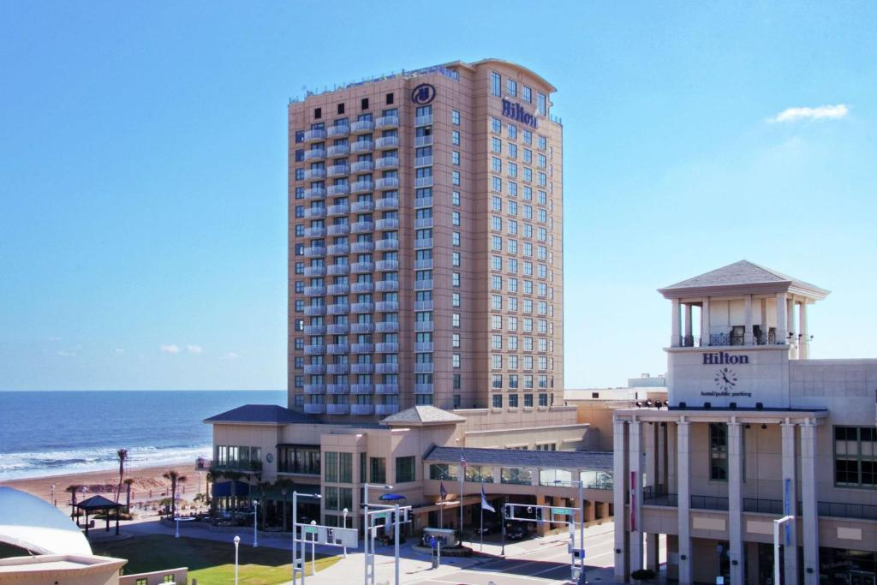

**Hilton Virginia Beach Oceanfront**

**3001 Atlantic Ave, Virginia Beach, VA 23451**

**47th Annual Symposium by the Sea 2025**

The 47th Annual Symposium By the Sea will be held at Hilton Virginia Beach Oceanfront, 3001 Atlantic Ave, Virginia Beach, VA 23451.

The VSRC is excited to provide another year of exceptional learning to our respiratory therapists. The SBS25 committee has put together an amazing three-day symposium that is filled with clinical practice, ventilator management, ethics, patient care techniques, and many more educational topics.

We have lots of vendors on site to provide device updates and practice for acute care, home care patients, and clinical practice.

**Conference Registration Rates:**

|  |  |
| --- | --- |
| **Early-Register by April 20, 2025** | **Late-Registration after April 20, 2025** |
| AARC Member all 3 days $300 | AARC Member $335 |
| Non-AARC Member all 3 days $325 | Non-AARC Member $360 |
| Student Member all 3 days $150 | Student Member $165 |
| **Two Day Conference Rate** | **Two Day Conference Rates** |
| AARC Member $240 | AARC Member $275 |
| Non-Member $265 | Non-Member $300 |
| Student Member $110 | Student Member $125 |

**Refund Requests will be accepted until May 5th 2025, and all requests will be subject to a 10% refund processing fee to cover Stripe fees charged to the VSRC.**

[https://www.vsrc.org/helpful-links/symposium-by-the-sea-attendee-registration/rginia Society for Respiratory Care](https://www.vsrc.org/helpful-links/symposium-by-the-sea-attendee-registration/rginia%20Society%20for%20Respiratory%20Care)

**Scan QR code to register or use link above.**



**Don’t have the extra money for registration? We need professional sputum bowl teams to participate in our sputum bowl! The 1st two teams to reach out with 3 members, will receive FREE 3 day registration!! You must attend and participate in sputum bowl on Tuesday night, or you will be charged registration fee. (Professional winners not sponsored to attend AARC Congress) If interested please email** [**vsrc411@gmail.com**](mailto:vsrc411@gmail.com)**, with team members names to receive discount code for registration.**

**Hotel Accommodations:**

Hotel accommodations will be at the Hilton Virginia Beach Oceanfront. A block of rooms is reserved in the name of **VSRC Symposium by the Sea 2025.** The rooms will be held until April 23, 2025.

**Click the link below for online reservations or scan QR code.**

<https://www.hilton.com/en/attend-my-event/orfvhhf-902-4807955b-bb45-4227-a40b-b1fdec9ca189/ium>

757-213-3000 Hilton Phone Number for reservations

** Hilton Virginia Beach Oceanfront Hotel Rates:**

City View: $159.00+tax per night

Ocean View: $179.00+tax per night

**Parking:**

**Parking Options for Overnight Hotel Guests Booked in the group block:**

**Option 1:** Guests who are booked within the group block receive self-parking in the garage **complimentary**.  Our current overnight self-parking charge is $25.00.  
Entrance is located on 30th street between Pacific Avenue and Atlantic Avenue, overnight guests will pull a ticket upon entry, park the vehicle starting on the 2nd floor, you must bring the parking ticket to the front desk for validation, front desk will provide the guests with a barcode that will be placed on the ticket that was pulled.  This allows for in-out privileges during their stay.

**Option 2:**Valet service is available at **$30.00 per day per vehicle.**  Valet is 24 hours. *This was a change from this year.  We changed the parking rate back in March but honored the old rate for this year's (2024) conference.

**Parking Options for People Attending an Event at the Hilton who are not Overnight Hotel Guests:**

**Option1:**Self-parking in the garage, entrance is located on 30th street between Pacific Avenue and Atlantic Avenue, Hourly rate is $2.00 with a maximum day rate of $20.00, payment by credit card only, cash is not accepted, park on Level 2 or higher, take the bridge walkway from the parking garage to the hotel, upon entering the hotel stay on the 2nd floor and continue to the event rooms.  The hotel is unable to validate self-parking tickets for free parking in the garage.  **Please note the city owns the parking garage and has the right to change the payment to pay upon entry meaning over the weekend they can do a flat entry free that guests need to pay prior to entering the garage.  The fee is $20.00 paid upfront. It does not matter how many hours you are in the garage.  
**Option 2:** Valet Parking, this service is available to people attending an event only (not overnight hotel guests) at no charge, inform the valet attendant you are attending an event, please allow additional time prior to the event start time, and additional time for retrieval of the car at the completion of the event. The valet service caters to not only guests attending events but also overnight guests and patrons dining at Catch 31.  While tips are not necessary, they are always appreciated.

**47th Annual Symposium by the Sea 2025**

**Program Agenda:**

|  |  |
| --- | --- |
| **Monday, May 19, 2025** | |
| 8:00 am - 8:55 am | Registration /Breakfast |
| 9:00 am - 12:30 pm | Lectures |
| 11:00 am - 11:30 am | Vendor Hall Open |
| 12:30 pm -2:00 pm | Lunch Provided |
| 2:00 pm - 5:00 pm | Lectures |
| 6:00 pm- ? | Social Night Party |
| **Tuesday, May 20, 2025** | |
| 8:00 am - 9:00 am | Breakfast with the Vendors |
| 9:00 am - 12 pm | Lectures |
| 12:00 pm - 1:00 pm | Lunch Provided |
| 1:00 pm - 4:00 pm | Lectures |
| 6:00 pm - 9:00 pm | Sputum Bowl |
| **Wednesday, May 21, 2025** | |
| 8:00 am - 9:00 am | Breakfast |
| 9:00 am - 12:00 pm | Lectures |
| 12:00 pm | Certificate Distribution after last lecture |
| ***See you in 2026!*** | |

**\*Speakers and topics subject to change without notice**

**Please reach out to Susan Arrington or Megan Keith with any questions**